### POST LAB TASK

Design and implement an embedded system to control the intensity of 220V AC light using variable resistor interfaced with controller using TRIAC and Zero Crossing Detector Circuit.

**PROTEUS SIMULATIONS**

#### Zero Crossing detector Circuit

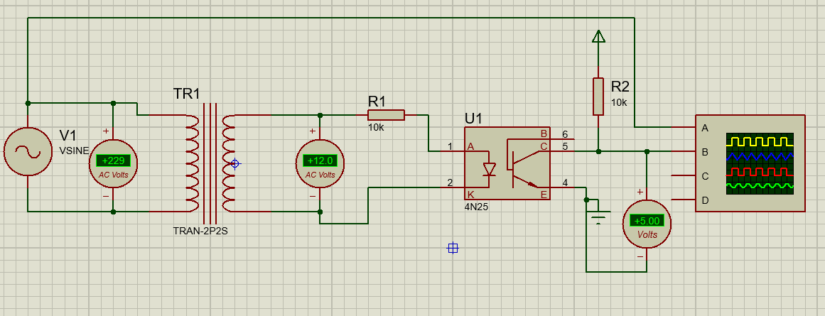

Figure 1: Zero Crossing Detector Circuit

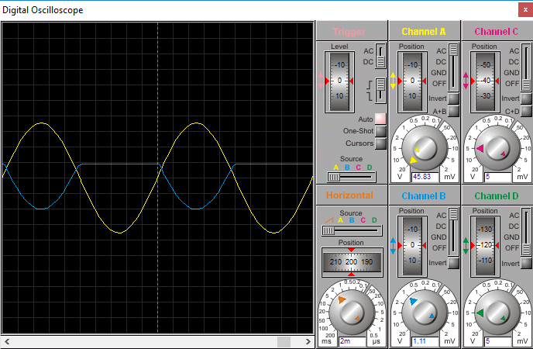

Figure 2: Zero Crossing detector circuit output

#### Triac Switching control Circuit:

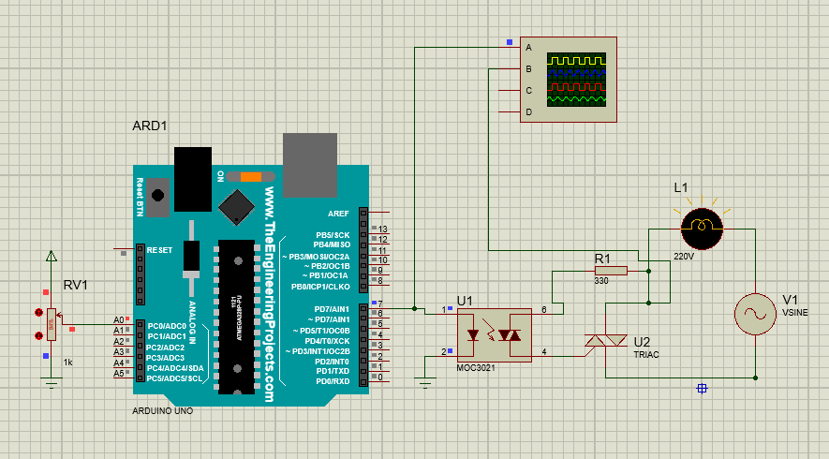

Figure 3: Potentiometer controlled firing angle of TRIAC

#### Final Circuit:

Figure 4: Gate Trigger Pulse Vs. AC switched by TRIAC

Figure 5: Arduino Code for switching potentiometer controlled TRIAC

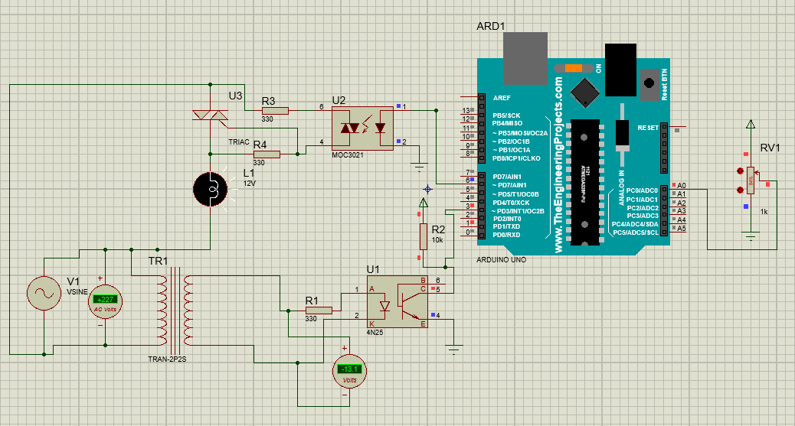

**ARDUINO IDE CODE:**

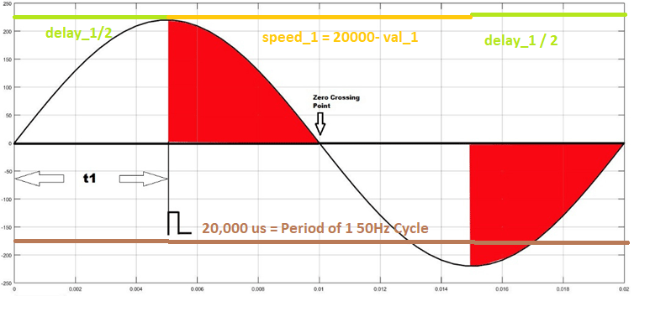

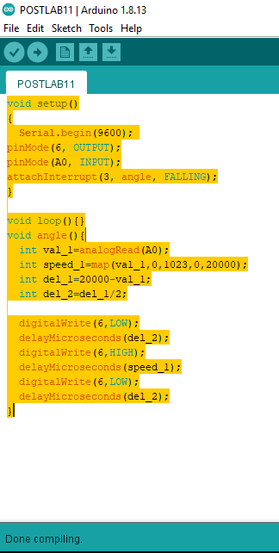

|  |
| --- |
| void setup()  {  Serial.begin(9600);  pinMode(6, OUTPUT);  pinMode(A0, INPUT);  attachInterrupt(3, angle, FALLING);  }  void loop(){}  void angle(){  int val_1=analogRead(A0);  int speed_1=map(val_1,0,1023,0,20000);  int del_1=20000-val_1;  int del_2=del_1/2;  digitalWrite(6,LOW);  delayMicroseconds(del_2);  digitalWrite(6,HIGH);  delayMicroseconds(speed_1);  digitalWrite(6,LOW);  delayMicroseconds(del_2);  } |